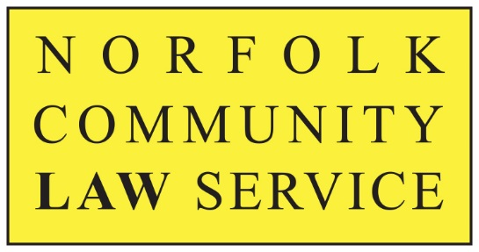
“Providing Access to Justice & Equality”

MEDIA RELEASE
Embargoed until 2nd November 2020, 09.00 GMT

Norfolk Community Law Service Celebrates
National Pro Bono Week 2020

During the last year the charity Norfolk Community Legal Service (NCLS) was able to offer Norfolk people an extra 1,000 hours of free legal advice valued at £150,000+, thanks to legal professionals giving their time and expertise voluntarily (called “pro bono” work).

2nd – 6th November is National Pro Bono Week and NCLS is celebrating the work of its pro bono team members across the county who support the charity with free, confidential and quality assured legal advice.

National Pro Bono Week celebrates the legal work which is carried out by solicitors, barristers and chartered legal executives and it is sponsored by the Law Society, the Bar Council and the Chartered Institute of Legal Executives (CILEx).

Judi Lincoln, NCLS’s Advice & Volunteer Manager, says:
“Norfolk has more legal professionals giving their pro bono support than anywhere else in the Eastern region. NCLS is lucky to have the pro bono expertise of 70 solicitors, 50 Law students at UEA and 20 community volunteers. Their combined efforts have helped us to continue running appointment booked free advice clinics by telephone and online even throughout the Covid pandemic, during which we saw a 15% increase in clients compared with last year. We are very proud to have them as part of our team.”

Rob Tiffen, Legal Director of Dispute Resolution at Birketts, has enjoyed giving pro bono advice at NCLS for 12 years and says:
“It’s very satisfying empowering people so they can take a case forward and solve their own problem. As a pro bono lawyer, you only get 15 minutes and you help people in very difficult circumstances, sometimes when they are very vulnerable, or perhaps aren’t used to dealing with solicitors and can feel a bit intimidated. So you really have to “think on your feet” and apply lateral thinking to solve problems quickly.
This intellectual investment can make a huge difference to someone’s life in a tangible way. For any law firm with a strong focus on Corporate Social Responsibility, doing regular pro bono work is a great opportunity for their professionals to “roll up their sleeves” and engage with their community. For me it brings both intellectual and emotional rewards. By choice, I’ve never been off the rota since 2008.”
Following on from the 15 minutes of free advice clients can sometimes get ongoing support from NCLS depending on the issue they present with, particularly relating to Domestic Abuse. During 2019/20 NCLS helped 3,071 clients across all its wide range of free advice services, which include Debt, Immigration, Welfare Rights, Domestic Abuse and Family Law.

Legal professionals in Norfolk who want to get involved with the vital work of NCLS, or people who need free advice or help can contact NCLS at info@ncls.co.uk or call 01603 496623.

Follow us on twitter @Nclawservice and Facebook Norfolk Community Law Service
ENDS
Notes to Editors:

For further information about the services and advice offered by NCLS please contact: Judi Lincoln on 01603 496623, email judi@ncls.co.uk

For media enquiries contact Helen Oldfield of Affinity PR, on 07974 502847, email helen@affinitypr.co.uk

You can view hi-res images here.
NCLS is a Registered Charity established in 1980. Its purpose is to provide access to justice and equality, by identifying unmet legal need across Norfolk and working with partner agencies (such as Norfolk Community Advice Network – NCAN) to provide free services to meet that need. We particularly target our services at people who are disadvantaged or made vulnerable by society, including ex-offenders, migrant workers, people with mental health issues and people facing domestic abuse. We prioritise according to need.
Our flagship service is our Legal Advice Service in Norwich on Tuesdays and Fridays which provides free, independent legal advice on family and employment as well as general matters. We also offer a free weekly session on Wednesdays giving advice on Domestic Abuse. We also run similar services on Tuesdays in Cromer and Great Yarmouth and Kings Lynn on Thursdays. All the advice is given by local solicitors on a pro bono basis and we could not provide the service without their generous contribution. These services have continued remotely and successfully since the pandemic.

NCLS is the lead agency for the Norfolk Community Advice Network (NCAN). https://norfolkcan.org.uk/

