During Pro Bono Week, 2-6th November 2020, we asked Rob Tiffen of Birketts LLP about his other role, as a pro bono volunteer with Norfolk Community Law Service (NCLS).

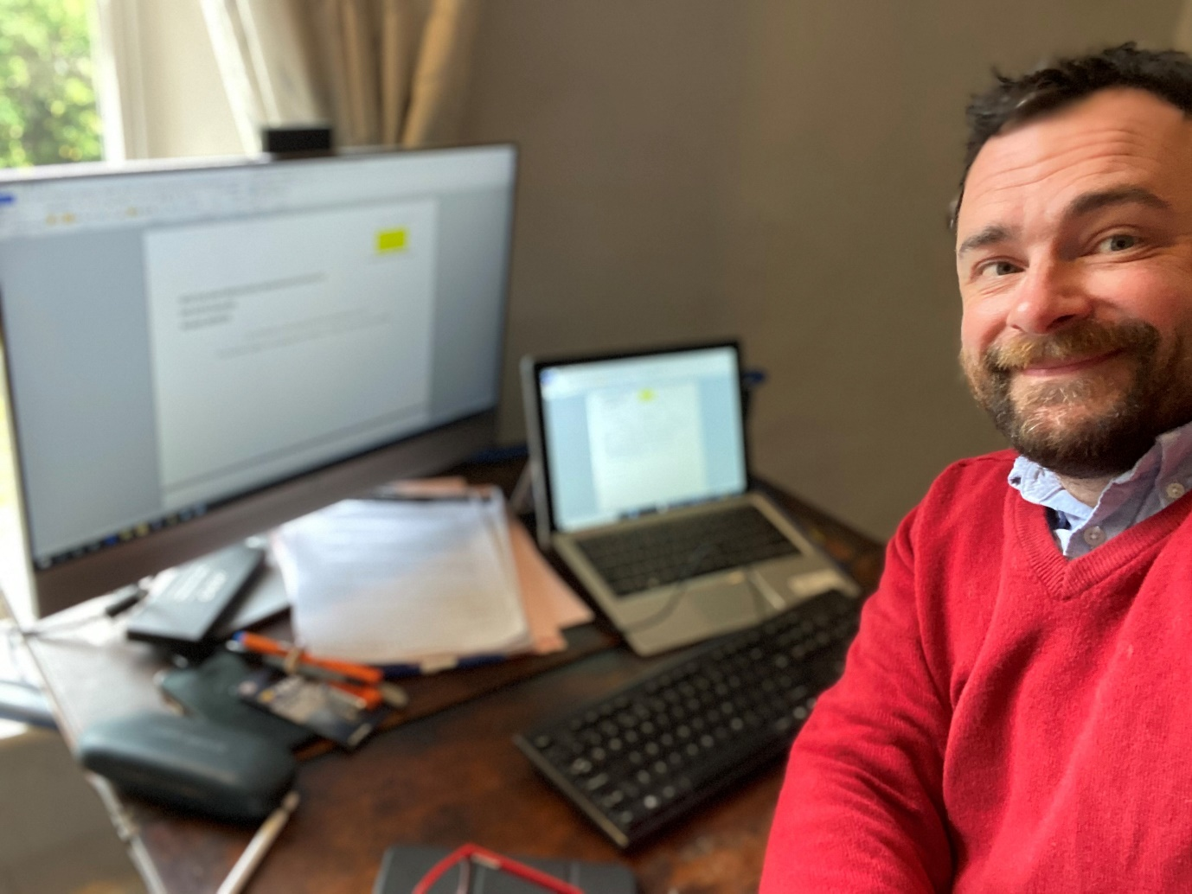

When did you begin at NCLS and what motivated you to step forward and volunteer?
I started doing pro bono volunteering with NCLS in 2008, not long after I qualified and right at the start of my career. I happen to be a little bit left-of-centre in my thinking, and it was an opportunity to give something back into the community and contribute in some way. I’ve always worked in business law (Rob is Legal Director of Dispute Resolution at Birketts LLP) so the opportunity to help people who I otherwise wouldn’t tend to come into contact with (because they aren’t business owners) was important to me.
I was also strongly encouraged to take part by people I was working with at that time. They came from an older Legal Aid tradition and told me stories of when they were first qualified, how they dealt with any legal query from any person that walked in off the street. They saw pro bono work as great way for young lawyers to learn what to do on the job. It still is.
You help people in very difficult circumstances, sometimes when they are very vulnerable, who perhaps aren’t used to dealing with solicitors and can be a bit intimidated. You don’t have a lot of time to think about it or to make detailed plans. As you only get 15 minutes, the client needs a practical steer on how to take forward their problem. These are all great skills for lawyers as otherwise they are stuck in a silo of law-school-to-law-firm and can miss out on “thinking on your feet” and in thinking practically and laterally.
I’ve been on the rota pretty much permanently for those 12 years.

What do you most enjoy about your pro bono role?
I think it’s that raw, basic satisfaction from helping people. One of the aspects of my job is almost “decoding” or translating the law, and boiling it down into something that is digestible for people, so that they can make smart decisions on what to do next, rather than just being blinded by the jargon and process of law.
Using your own intellect to help them to make their own choice and take ownership of their situation, I just find that really rewarding. Sometimes they might be in an argument (in a dispute with a business, for example) and just want my endorsement of their position. When you can do that and encourage them to “crack on”, then you see their relief and determination just because their position is acknowledged and endorsed. Empowering other people so they can take something forward and solve their problems is very satisfying.

What’s “in it” for your law firm? i.e. why is pro bono work considered by your industry to be a “good thing to do”?
Generally, law firms still recognise the value of those original pro bono skills and experiences that I was encouraged to engage with. It’s still valuable to get new lawyers out of thinking they are still in law school and into practical problem solving.
Most law firms also like to contribute back into their communities via a strong CSR push and it’s important nowadays that firms roll up their sleeves and get involved, so this is a regular way lawyers can do that.
More broadly, the legal profession probably recognises that it is an affluent profession and that most lawyers generally do well for themselves, so there has always been this trend within the profession that it’s an intellectual investment which adds some balance.

Can you tell me about a particular pro bono case that you worked on which has stayed with you?
It’s very difficult to recall every person’s outcome in detail, as we only get a snapshot into what happens with them, and we never see them again in most circumstances.
I helped one client that had been mis-sold a product so she signed up with a claims company to manage her claim. They didn’t do a very good job and her case went quiet, so then she signed up with a different company. After the claim succeeded, her original claims company came out of the woodwork and wanted their commission too. She came back 2 or 3 times and we took this argument further and further until they settled. She stood out because she was great and super relaxed all the way through it! At one point they were threatening to bankrupt her and still she carried on. Often clients are on edge and anxious about it. She stood out for the opposite reason!
With another case, the client was a student and her landlord had been difficult after she’d given notice to move on. She had already worked out by herself how the law works around the Tenant Deposit Scheme works and how landlords are supposed to put the deposit into a regulated scheme – and he hadn’t done that - and that the tenant could now claim compensation. I told her she could crack on, it was more about encouraging her to feel confident to go forward and get what she was entitled to. Other potential cases emerged by taking that action (because lots of students were in a similar position with the same landlord), and ended up being a conversation about how her case might make that landlord treat his tenants better in future. Again, that was so unusual and memorable in that someone had worked it all out for themselves. My role with her became more like a mentor.
Over the last 4 of 5 years I’ve more frequently helped Litigants in Person (someone representing themselves when issuing legal proceedings). Often it’s someone who is perfectly bright and sensible but still out of their depth in dealing with Court proceedings. Sometimes it can be a vulnerable person with mental health issues, who needs help dealing with their case. The increase in Litigants in Person is because Legal Aid has been cut over the years and not everyone can afford to hire a solicitor.
What would you say to other solicitors or law firms that are not currently involved in pro bono volunteering?
“I’d really encourage them to at least give it a try because although it looks a bit daunting or like something that’s a bit of a chore, actually helping people in this tangible way is both intellectually and emotionally rewarding. You get a good feeling, more powerful than you might appreciate.”

